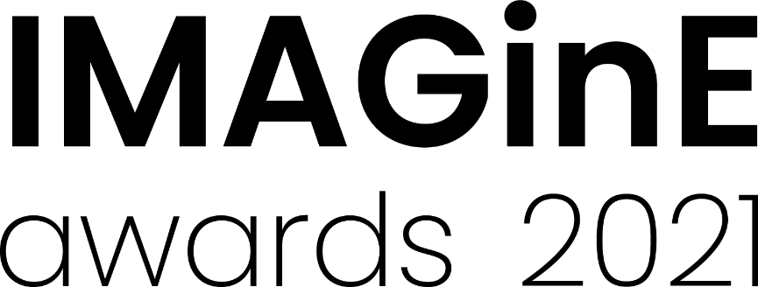
Innovation and Resilience award
2021 Nomination form
Nominations close: 5pm, 26 August 2021
Nominations can be for ongoing projects where the majority of the activity occurred between 1 July 2020– 30 June 2021.
The Innovation and Resilience award recognises the outstanding efforts of museums and galleries during hardship and celebrates excellence and innovation in exhibition practice, resilience building projects and engagement programs. Nominations can include (but are not limited to) projects that:
- Foster ways to effectively engage the local community in creative, community focused activities that build local capacity and capability for resilience
- Develop effective partnerships and build networks between local community organisations, councils, businesses and/or emergency services agencies
- Support initiatives that can be integrated into current business and maintained in the longer term
- Programs demonstrating sustainable environment practices
- Significant collection management programs
Please refer to the M&G NSW website for examples of past programs which have been successful in this category.
Please tick the box for the award to which you are applying
(A) Innovation and Resilience award for projects with a budget of $10,000 or less
(B) Innovation and Resilience award for projects with a budget of between $10,001 and $100,000
(C) Innovation and Resilience award for projects with a budget of $100,001 or greater
Selection criteria
- Quality of the program’s aims and achievements
- The extent of the program’s impact on the resilience of the organisation and community
- A well planned and innovative program that is clearly articulated
Nomination details
Name of museum, gallery or Aboriginal cultural centre being nominated for the award:

Title of project:

Dates of project:

Nominator details (Person completing this form)
Nominating Organisation (if different from above)
Contact person: Position:
Phone: Email:
Traditional place name (if known):
Street address: Suburb:
State: Postcode:
Postal address (if different from above): Suburb:
State: Postcode:
Number of full time paid staff equivalent that worked on this project:
Number of volunteers that worked on this project:
Project budget:

Project details
Provide a short description of the organisation (max. 100 words)
You may wish to include the organisation’s mission statement/vision

Provide an outline of the project (max. 50 words)
This summary should give a clear, concise overview of the project.

Describe the project, including why it should win an award (max. 250 words)
This description may be edited and used in promotional material. Please refer to the M&G NSW Website to read the program descriptions of previous award winners.

Describe the impact the program has on the resilience of the organisation and community
(max 250 words)

Support material
The following support material must be submitted with your nomination:
- Up to THREE pages (maximum) of documentation which supports the nomination
(this can include images, suggested file formats are word doc, pdf or powerpoint)
File No. | Support Material details (i.e. image details, name of document)
1
2
3

AND
- TWO high quality images of the nominated program (300 dpi jpegs max. 2MB each). These images will be used in online and printed promotional material and at the awards presentation.
Image No. | Image file name | Image credit for promotional use
1
2

These image credits will be used in promotional material and social media wherever possible.
Please refer to the 2021 Guidelines for details on how to prepare and submit your support material.
Nomination checklist
Completed nomination form
Provided required support material
Declaration by nominator
I give my assurance that, to the best of my knowledge, the information supplied in this nomination is true and correct at this date. I agree to abide by the IMAGinE awards’ Terms and Conditions of Entry.
I accept.
Date:

How to submit your nomination
All nomination forms and support material must be submitted online by the closing date via the M&G NSW IMAGinE awards webpage: https://mgnsw.org.au/sector/support/imagine/
To prepare your entry for submission save this document with your organisations name and category you are entering. Please use an underscore ( _ ) to separate words. For example: OurMuseumGallery_ResilienceProject.doc

IMAGinE awards night
The awards will be presented at the Chau Chak Wing Museum, The University of Sydney on Thursday 25 November, 3:30 – 5pm followed by an evening in the museum.
The award ceremony will be streamed live for those who cannot travel.

