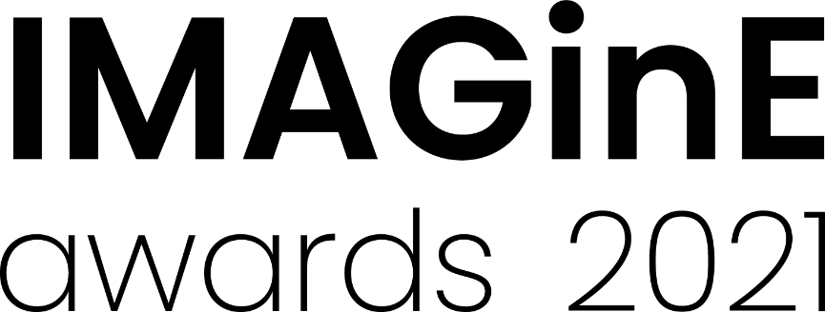
Imagination award
2021 Nomination form
Nominations close: 5pm, 26 August 2021
Nominated projects should be planned to take place between 1 Dec 2021 – 30 June 2022
Do you have an idea for a new project, exhibition or a way to make your cultural environment more vibrant? This year we are seeking proposals for projects demonstrating creative and innovate approaches to exhibitions and engagement projects to receive a $3,000 cash grant prize.
We are searching for innovative concepts that use your museum or gallery in a new way, that appear in unexpected places, or that reimagine landmark sites. We want to support ideas involving and inspiring the local community, utilising technology to counteract physical isolation, or connecting with new audiences.
Proposed projects can include (but are not limited to) the following:
- Activations of outside spaces such as gardens and carparks
- Collaborations with local artists and community groups
- Community takeovers of facilities and programs
- Ephemeral installations
- Hands on and tactile learning

Please tick the box for the award to which you are applying
Museums/Heritage Galleries/Visual Arts
Please check the 2021 Guidelines for eligibility or contact M&G NSW via imagine@mgnsw.org.au or 0412425047

Judging criteria
- Quality and relevance of the project’s aims and achievements
- Capacity of the project to engage audiences and inspire community
- A creative and innovative project that is clearly articulated
- A unique idea that is particularly remarkable, special, or unusual.
Nomination details
Name of museum, gallery or Aboriginal cultural centre being entered for the award:

Title of project:

Proposed dates of project:

Nominator details (Person completing this form)
Nominating Organisation
Contact person: Position:
Phone: Email:
Traditional place name (if known):
Street address: Suburb:
State: Postcode:
Postal address (if different to above): Suburb:
State: Postcode:

Project details
Provide a short description of the organisation (max. 100 words)
You may wish to include the organisation’s mission statement/vision

Provide an outline of the project (max. 50 words)
This summary should give a clear, concise overview of the project.

Describe the project, including the proposed audience and what makes is special or unique (max. 200 words)
This description may be edited and used in promotional material and awards booklet. Please refer to the M&G NSW website to read the project descriptions of previous award winners.

Creative Proposal
Creative proposals can be as creative as you like in how they communicate the core idea and can include photo essays, illustrations, diagrams, recorded interviews, music etc.
Proposals should consider the judging criteria and aim to describe the project using images text and/or audio, including why it should win an award. The proposal should also address the intended audience and the aims of the project? The focus of the proposal should be on the idea not the logistics of making it happen. Only successful entries will be required to submit a budget.

Accepted formats are video (MP4 or .Mov files up to a maximum of 3 min), powerpoint (max 10 slides), images (max 10 jpeg files), pdf (max 10 pages) or a combination of images and pdfs (max 10 files where each pdf page is equivalent to 1 file)

Please refer to the 2021 Guidelines for details on how to prepare and submit your support material.
Declaration by nominator
I give my assurance that, to the best of my knowledge, the information supplied in this nomination is true and correct at this date. I agree to abide by the IMAGinE awards’ Terms and Conditions of Entry.
I accept.
Date:

How to submit your nomination
All nomination forms and creative proposals must be submitted online by the closing date via the M&G NSW IMAGinE awards webpage: https://mgnsw.org.au/sector/support/imagine/
To prepare your entry for submission save this document with your organisation’s name and category you are entering. Please use an underscore ( _ ) to separate words. For example: OurMuseumGallery_Exhibition.doc

IMAGinE awards night
The awards will be presented at the Chau Chak Wing Museum, The University of Sydney on Thursday 25 November, 3:30 – 5pm followed by an evening in the museum.
The award ceremony will be streamed live for those who cannot travel.

