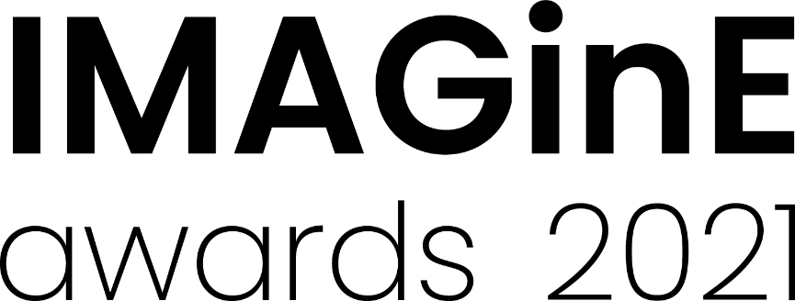
Exhibition Projects
2021 Nomination form
Nominations close: 5pm, Thursday 26 August 2021
Projects are eligible where the majority of the activity occurred between 1 July 2020– 30 June 2021.
Projects can include (but are not limited to) the following:
- Strong community and audience engaged projects and related programs
- Innovative and significant permanent or temporary exhibitions
- Projects that attracted media interest
- Successful exhibition design projects
- Projects where partnerships were important to the development of the exhibition
- Publications and resources produced in conjunction with the exhibition
Please refer to the M&G NSW website for examples of past programs which have been successful in this category.
Please tick the box for the award to which you are applying
Museums/Heritage Galleries/Visual Arts
(A) Exhibition Projects award for small organisations
(B) Exhibition Projects award for medium organisations
(C) Exhibition Projects award for large organisations

Please check the 2021 Guidelines for how to determine your organisation’s size or contact M&G NSW via imagine@mgnsw.org.au or 0412 425 047

Selection criteria
- Quality and relevance of the project’s aims and achievements
- Capacity of the project to engage audiences
- A well planned and presented project that is clearly articulated
Nomination details
Name of museum, gallery or Aboriginal cultural centre being nominated for the award:

Title of project:

Dates of project:

Nominator details (Person completing this form)
Nominating Organisation (if different from above)
Contact person: Position:
Phone: Email:
Traditional place name (if known)
Street address: Suburb:
State: Postcode:
Postal address (if different to above): Suburb:
State: Postcode:
Number of full time paid staff equivalent that worked on this project:
Number of volunteers that worked on this project:
Project budget: Project visitation (if applicable):

Project details
Provide a short description of the organisation (max. 100 words)
You may wish to include the organisation’s mission statement/vision

Provide an outline of the project (max. 50 words)
This summary should give a clear, concise overview of the project.

Describe the project, including why it should win an award (max. 200 words)
This description may be edited and used in promotional material and awards booklet. Please refer to the M&G NSW website to read the project descriptions of previous award winners.

Describe any partnerships with external organisations and/or individuals and how they contributed to this project (max. 100 words)
(eg. Funders, consultants, curators, artists etc.)

How was your target audience engaged and how successful was their involvement? (max. 200 words)
Include qualitative and quantitative evidence where possible

Support material
The following support material must be submitted with your nomination:
- Up to THREE pages (maximum) of documentation which supports the nomination
(this can include images, suggested file formats are word doc, pdf or powerpoint)
Support Material details (i.e. image details, name of document)
1
2
3

AND
- TWO high quality images of the nominated program (300 dpi jpegs max. 2MB each). These images will be used in online and printed promotional material and at the awards presentation.
Image No. | Image file name | Image credit for promotional use
1
2

These image credits will be used in promotional material and awards booklet.
Please refer to the 2021 Guidelines for details on how to prepare and submit your support material.
Nomination checklist
Completed nomination form
Provided required support material

Declaration by nominator
I give my assurance that, to the best of my knowledge, the information supplied in this nomination is true and correct at this date. I agree to abide by the IMAGinE awards’ Terms and Conditions of Entry.
I accept.
Date:

How to submit your nomination
All nomination forms and support material must be submitted online by the closing date via the M&G NSW IMAGinE awards webpage: https://mgnsw.org.au/sector/support/imagine/
To prepare your entry for submission save this document with your organisation’s name and category you are entering. Please use an underscore ( _ ) to separate words. For example: OurMuseumGallery_Exhibition.doc

IMAGinE awards night
The awards will be presented at the Chau Chak Wing Museum, The University of Sydney on Thursday 25 November, 3:30 – 5pm followed by an evening in the museum.
The award ceremony will be streamed live for those who cannot travel.

